Assignment No. 2

CWID: 805613197

CPSC 558

Name: Chirag Padsala.

Solutions:

1: Mac address

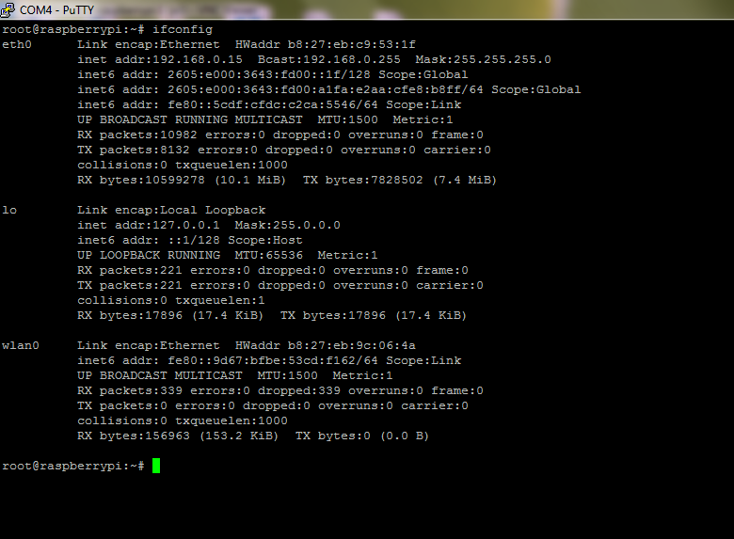

2. VLAN

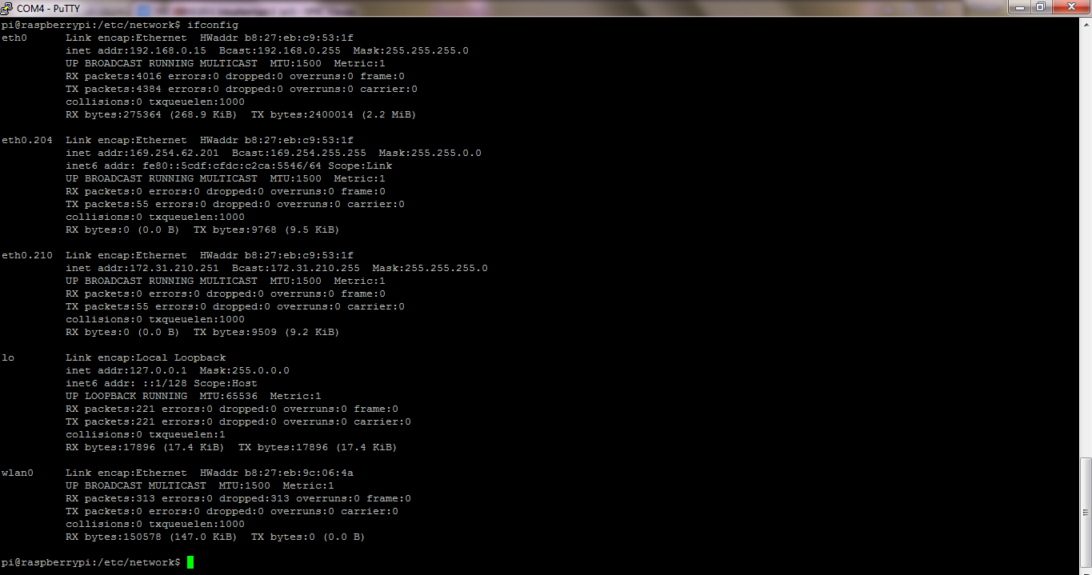

3: Ping

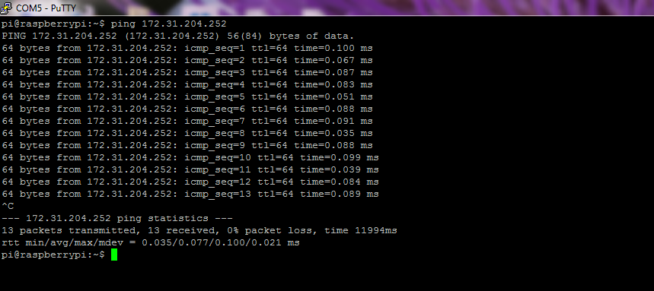

4: Pcap Screenshot

